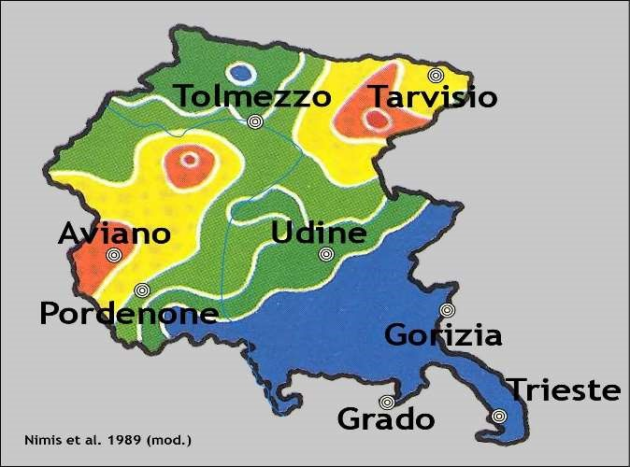
AVIANO Reunion 2021 Itinerary
NOTE: Due to the COVID pandemic, our scheduled September 2020 itinerary was postponed to September 11-18, 2021. Below is the itinerary that was scheduled for 2020. It is anticipated that we will visit most if not all of these locations and include the same events, meals and amenities. Only the start date and end date are shown for now. As the itinerary is coordinated in Italy, we will revise this itinerary, adding dates and any changes needed.
As most of us veterans learned when we were on active duty, stay flexible.

DAY 1 SEPT 11– Arrival and late-morning pick-up at two places only: Venice Marco Polo Airport (https://www.veniceairport.it/en/) and at the Hotel Venice Resort (https://www.hotelveniceresort.com/en). Transfer to Sacile, our home for seven nights at the Hotel Due Leoni (https://www.hoteldueleoni.it/en/). Welcome Cocktail sponsored by Tours by Roberto, followed by ARA Welcome and Business Meeting. Dinner to follow at a local restaurant (one-minute walk from the hotel). D
DAY A – Aviano Air Base Tour (https://www.aviano.af.mil). Tour departure time TBD. Aviano is home of the 31st Fighter Wing, flying F-16s. Lunch probably at the base. More details on this tour will be available later. Lunch and dinner on your own. B
DAY B – Depart Sacile at 9 am. Walking tour of Trieste (https://www.lonelyplanet.com/italy/friuli-veneziagiulia/trieste) starts at 10:30 am. Trieste was the main northeast port of Italy with a multi-ethnic population who left behind beautiful architecture and cultural diversity. Lunch in Trieste with more touring after lunch. Return to the hotel around 4:00 pm with dinner in Sacile: B L D
DAY C — Depart at 9 am. Tour of Aquileia (https://whc.unesco.org/en/list/825/) and Palmanova, (https://www.atlasobscura.com/places/palmanova-star-fortress-city), both of which are UNESCO World Heritage Sites. In Aquileia, which served as a strategic frontier fortress for Northeast Italy, we will see the most well-preserved Roman Christian Basilica containing beautiful mosaics and notable Roman ruins. Lunch will be in Aquileia, followed by a visit to Palmanova with military fortifications built for the defense of Venice in the 15th-17th century. We will also visit the Palmanova Museum of WWI. Dinner in Sacile. B L D
DAY D—Depart at 9 am for Villa Maser in Asolo, a perfect example of a Palladian villa (https://www.italythisway.com/places/asolo.php). After the visit of the villa and its winery, we will visit Marostica (https://www.venetoinside.com/discover-veneto/venice-art-cities/vicenza/surroundings/marostica/), once a Venetian city which preserves its Venetian architecture. There we will sit in reserved seats and enjoy a great spectacle which takes place only every two years. It is a human chess game in the main square, played by human “pieces,” armed and marked in black and white as dictate by old rules of the “noble art.” Light dinner in Marostica and return to Sacile. B L D
DAY E—Depart for Vicenza (http://www.italyheaven.co.uk/veneto/vicenza.html) at 9 am. Walking tour of the city, one of the most elegant in Northeast Italy, with many palaces designated by Andrea Palladio, of which great examples are the Basilica and Palazzo Chiericati. Lunch in a local restaurant, followed by some shopping time. Return to Sacile around 4 pm. Dinner in Sacile. B L D
DAY F—Depart at 9 am for San Daniele del Friuli. There we will visit the factory of the famous prosciutto of San Daniele, (http://www.italia.it/en/travel-ideas/gastronomy/san-daniele-prosciutto-an-italian-legacy.html) and will be hosted by a local producer, who, after showing us the techniques of prosciutto production, will offer us a nice lunch based on his products. After lunch we will continue to the medieval castle of Valvasone, where we will meet with a local group who, besides guiding us around the beautiful castle, will demonstrate typical dancing and music and treat us to an exclusive organ concert in the cathedral. Return to Sacile to celebrate our farewell dinner that will be held in the nearby Villa Luppis. B L D
DAY 8— SEPT. 18 Group departure for the Venice Airport and Venice Cruise Port. Time depending on flight schedules. We will also provide one group departure for the Hotel Venice Resort. B
NOTE that for 2021, the new cruise schedule allows the cruisers to board the ship on the same day that our reunion ends, September 18.

